ReactJS HOL-2 Solution

Home.js
import React,{Component} from 'react';
export default class Home extends Component{
render(){
return <h2>Welcome to the Home Page of Student Management Portal</h2>;
}
}

About.js
import React,{Component} from 'react';
export default class About extends Component{
render(){
return <h2>Welcome to the About Page of Student Management Portal</h2>;
}
}

Contact.js
import React,{Component} from 'react';
export default class Contact extends Component{
render(){
return <h2>Welcome to the Contact Page of Student Management Portal</h2>;
}
}

App.js
import Home from './Components/Home';
import About from './Components/About';
import Contact from './Components/Contact';
function App(){
return(
<div>
<Home/>
<About/>
<Contact/>
</div>
);
}
export default App;

Output
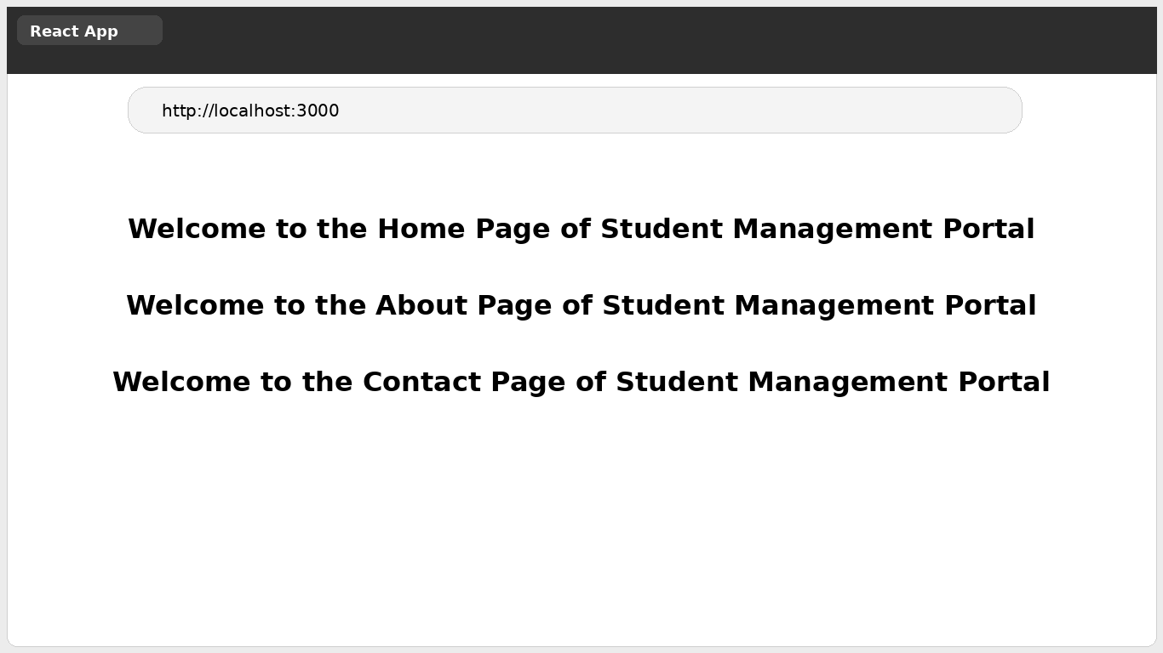

Conclusion
The Student Management Portal application was successfully created using React components and all three components were rendered correctly.

